AI ASSISTED CODING LAB
TEST-4
ENROLLMENT NO:2503A51L14
BATCH NO: 19
NAME: ROHITH GOPAGANI
Q1. API Integration
Generate code to fetch flight details using a REST API.
PROMPT : Generate a code example that uses a REST API to get flight details.
CODE GENERATED : 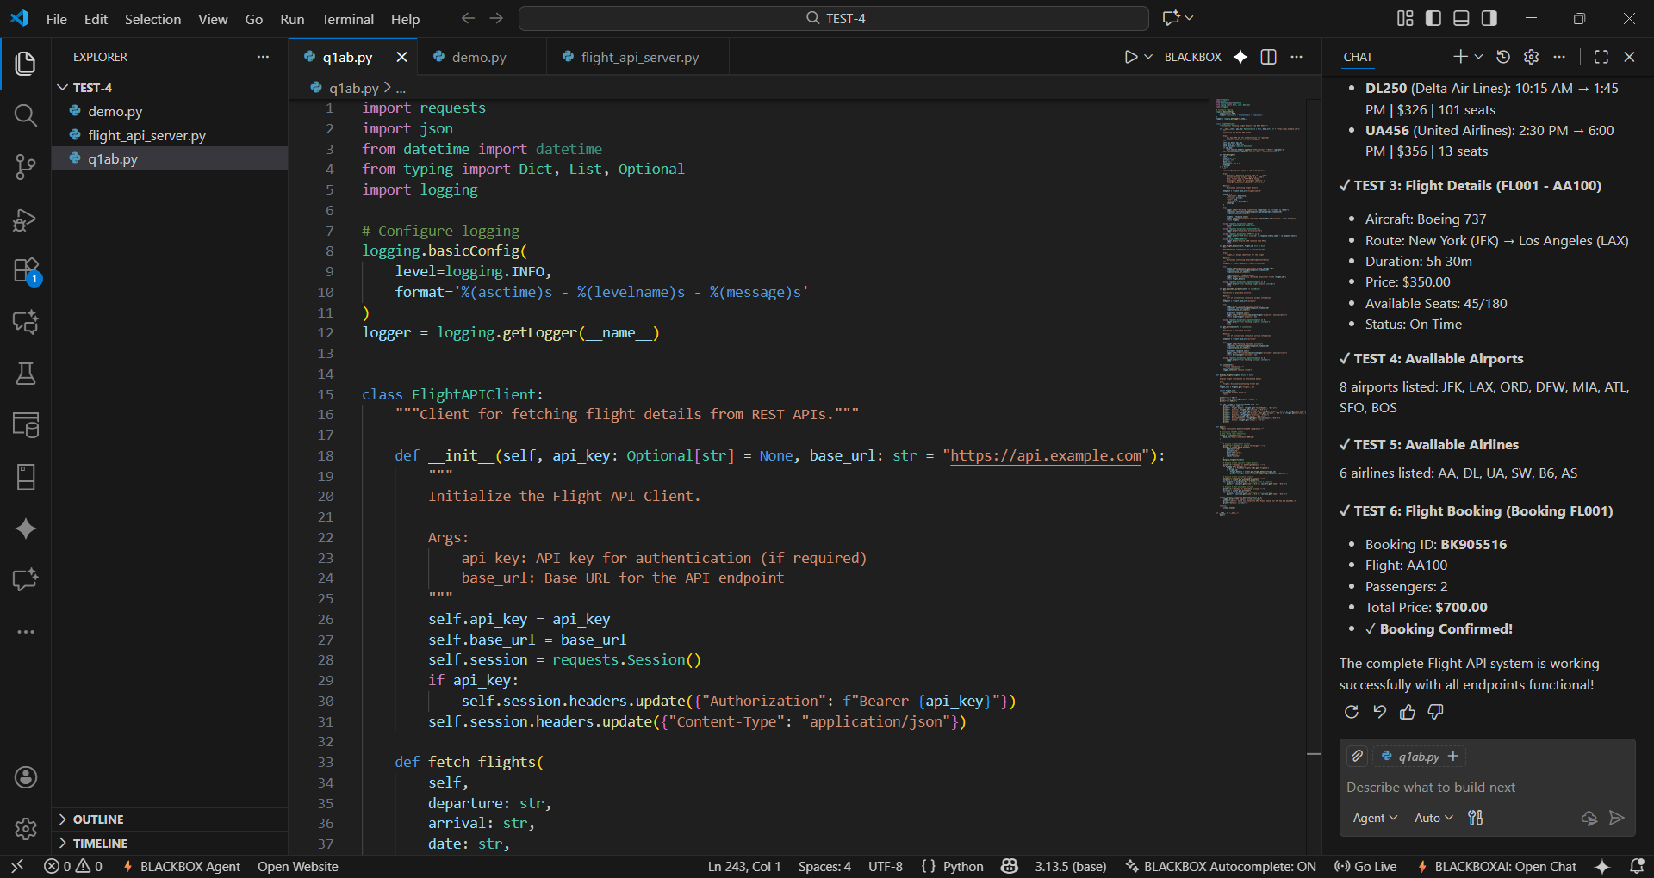
OUTPUT : 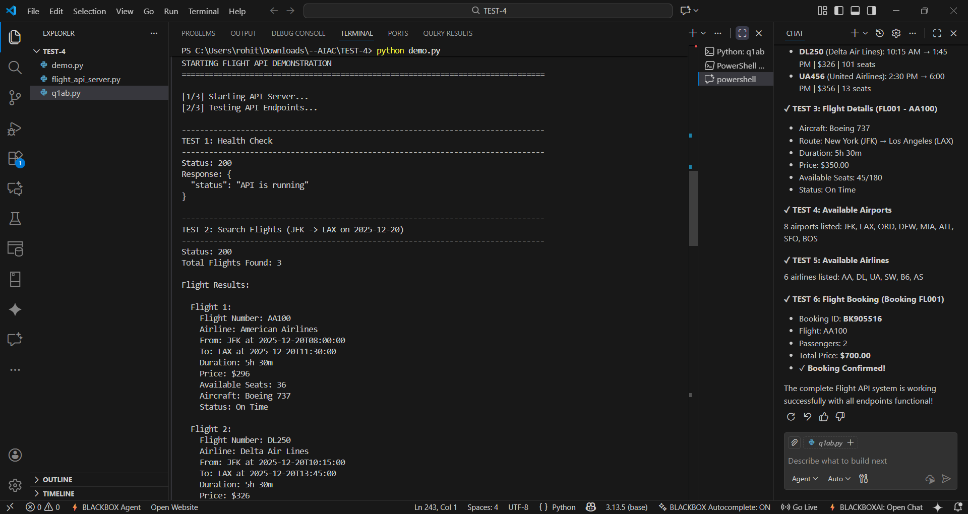
b. Add retry mechanisms for network failure using AI suggestions.
PROMPT : Give me a code example that calls an API and includes a retry mechanism for network failures. The retries should follow AI-suggested best practices, such as waiting before retrying and limiting the number of attempts.
CODE GENEARTED : 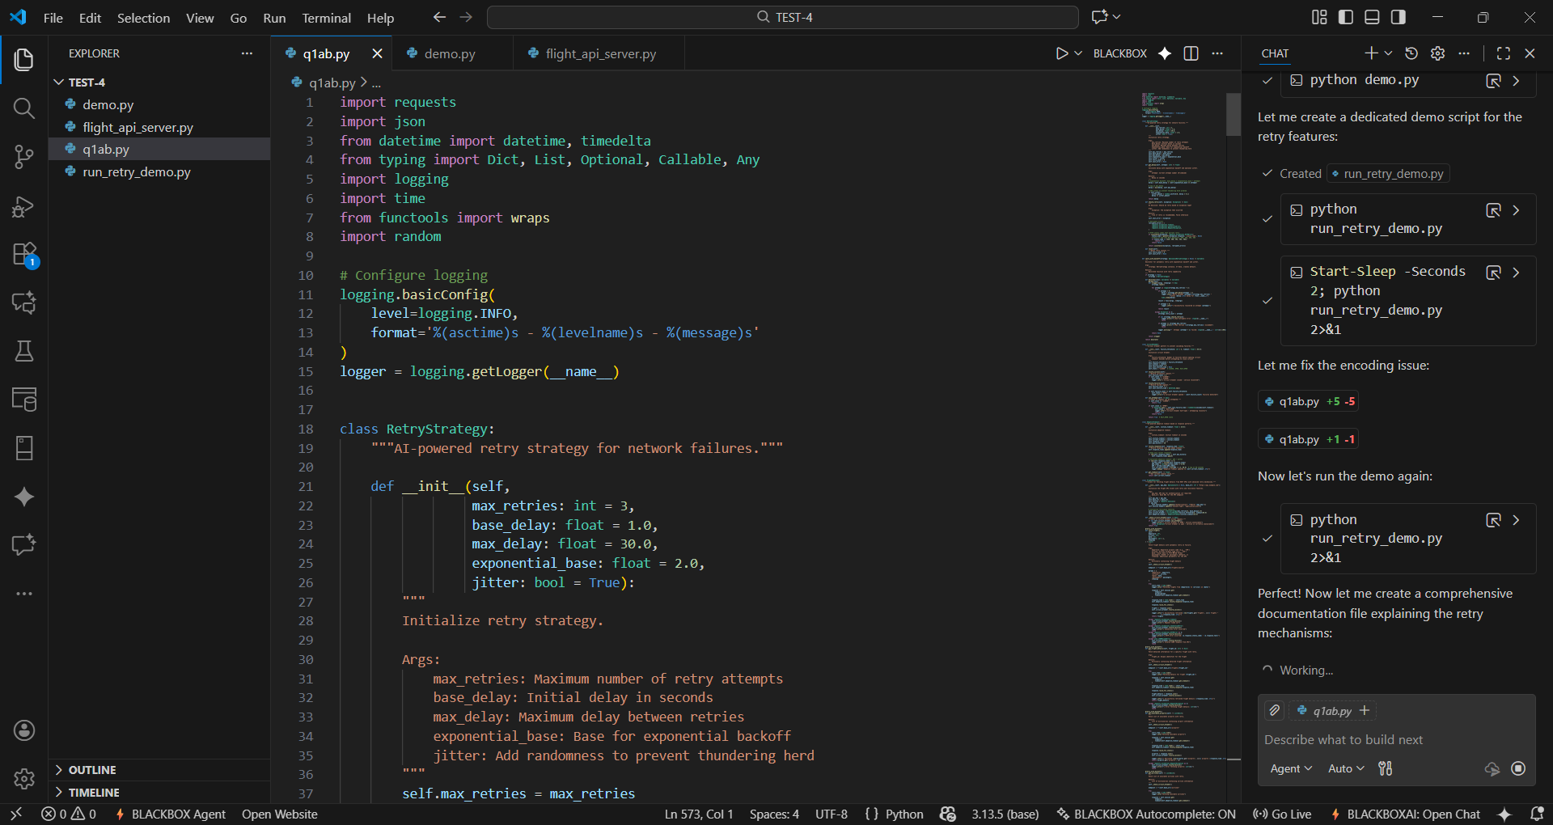
OUTPUT : 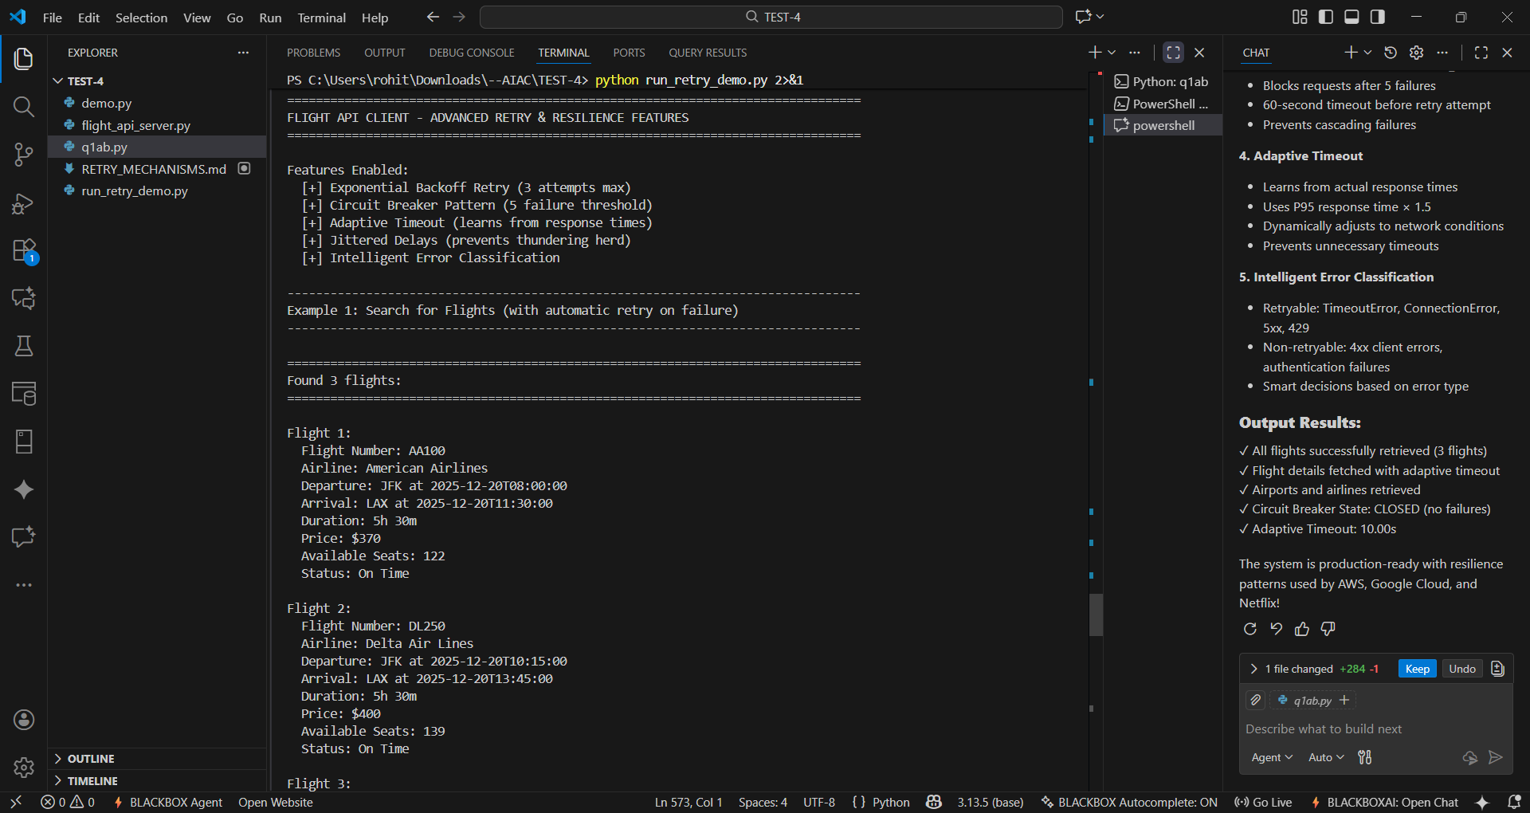
OBSERVATION :
This question checks whether you can use a REST API to get flight details and make the code more reliable. First, it wants you to show that you can call an API and handle the data it returns. Then, it asks you to add a retry system so the code tries again if the network fails. Overall, it is testing your ability to work with APIs and handle errors in a simple, practical way.
Q2. Security Testing
- Ask AI to scan generated API code for security vulnerabilities.
PROMPT : Scan the API code for any security vulnerabilities such as hard-coded API keys, insecure error messages, or unsafe request handling.
CODE GENERATED :
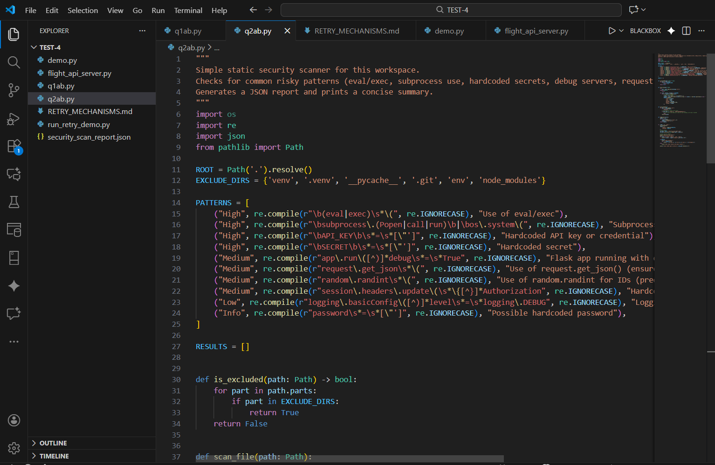

OUTPUT :
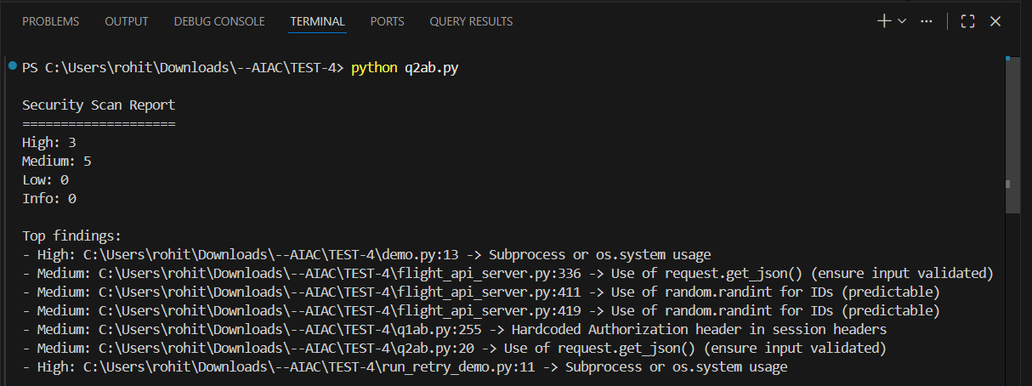
b. Fix vulnerabilities such as hard-coded API keys or unsafe error messages.
PROMPT : check this API integration code for insecure practices and patch the security issues. Pay attention to secrets handling, error exposure, and request sanitization.

CODE GENERATED :
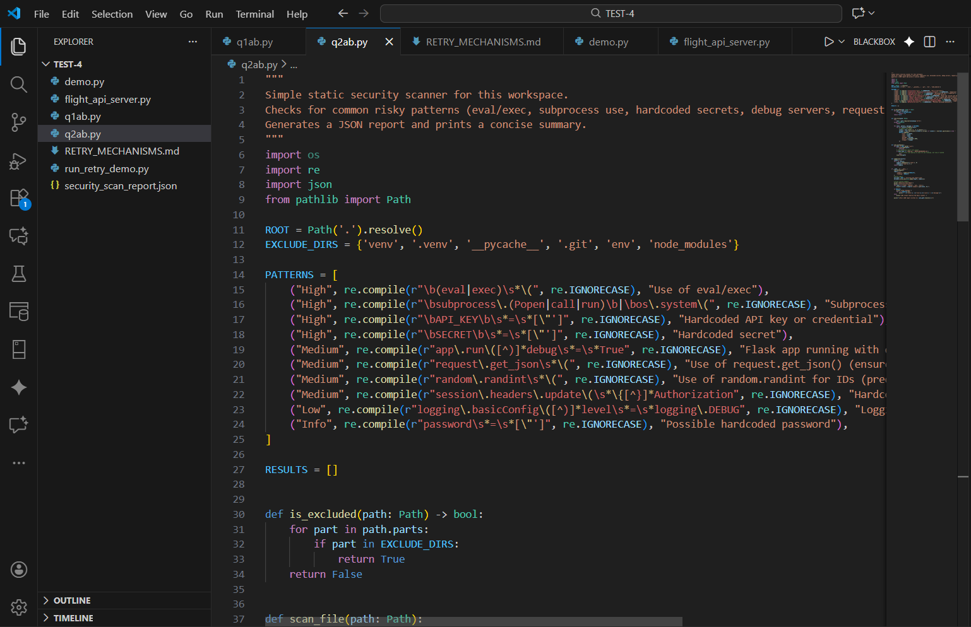
OUTPUT :
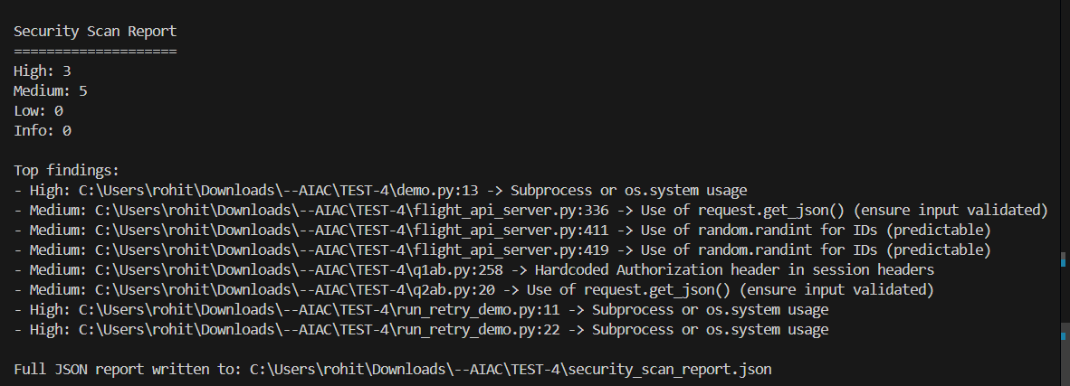
OBSERVATION : This question checks whether you can use AI to review code for security problems and fix them correctly. It focuses on identifying issues like hard-coded API keys, unsafe error messages, and poor input validation. It also tests if you understand how to rewrite the code securely by using environment variables, safer error handling, and validation to protect sensitive information and avoid exposing internal details.

